

COURSE: | DATABASE SYSTEMS
LAB: | # 15
NAME: | MUZAMMIL BIN SOHAIL
ROLL NO.: | 22F - 3110
DEGREE: | BS - AI
SECTION: | 4A1

Question 1:
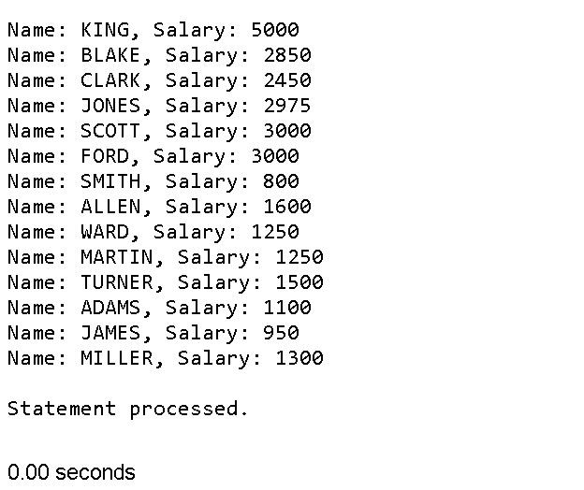
DECLARE
CURSOR employee_cursor IS
SELECT ename, sal FROM emp;
BEGIN
FOR employee_record IN employee_cursor LOOP
DBMS_OUTPUT.PUT_LINE('Name: ' || employee_record.ename || ', Salary: ' || employee_record.sal);
END LOOP;
END;
Question 2:
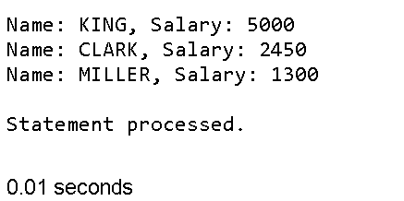
DECLARE
CURSOR department_cursor (dept_id NUMBER) IS
SELECT ename, sal FROM emp WHERE deptno = dept_id;
BEGIN
FOR employee_record IN department_cursor(10) LOOP
DBMS_OUTPUT.PUT_LINE('Name: ' || employee_record.ename || ', Salary: ' || employee_record.sal);
END LOOP;
END;
Question 3:
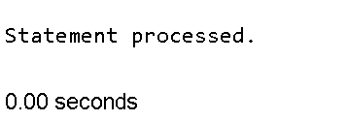
BEGIN
FOR employee_record IN (SELECT ename, sal FROM emp WHERE sal > 5000) LOOP
DBMS_OUTPUT.PUT_LINE('Name: ' || employee_record.ename || ', Salary: ' || employee_record.sal);
END LOOP;
END;
Question 4:
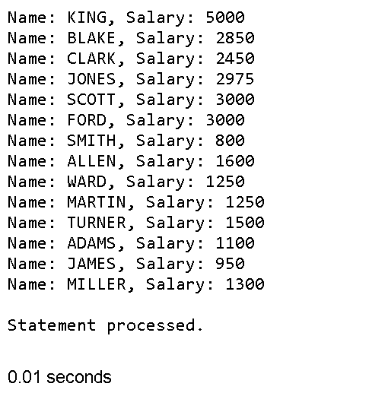
DECLARE
TYPE ref_cursor IS REF CURSOR;
dyn_cursor ref_cursor;
dyn_query VARCHAR2(100);
employee_record emp%ROWTYPE;
BEGIN
dyn_query := 'SELECT * FROM emp';
OPEN dyn_cursor FOR dyn_query;
LOOP
FETCH dyn_cursor INTO employee_record;
EXIT WHEN dyn_cursor%NOTFOUND;
DBMS_OUTPUT.PUT_LINE('Name: ' || employee_record.ename || ', Salary: ' || employee_record.sal);
END LOOP;
CLOSE dyn_cursor;
END;
Question 5:
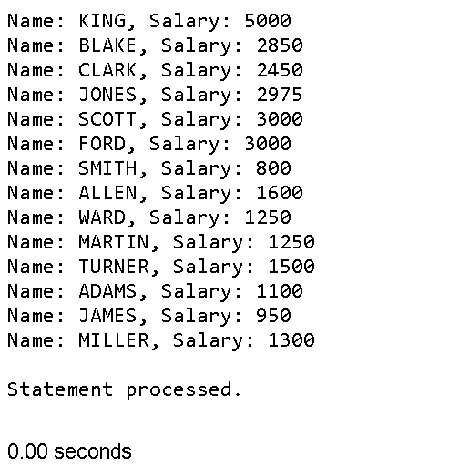
DECLARE
CURSOR employee_cursor IS
SELECT ename, sal FROM emp;
BEGIN
FOR employee_record IN employee_cursor LOOP
DBMS_OUTPUT.PUT_LINE('Name: ' || employee_record.ename || ', Salary: ' || employee_record.sal);
END LOOP;
END;
Question 6:
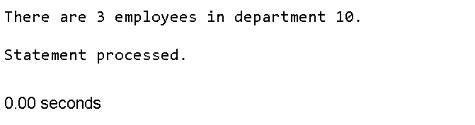
DECLARE
CURSOR department_count_cursor IS
SELECT COUNT(*) FROM emp WHERE deptno = 10;
count_record NUMBER;
BEGIN
OPEN department_count_cursor;
FETCH department_count_cursor INTO count_record;
IF department_count_cursor%FOUND THEN
DBMS_OUTPUT.PUT_LINE('There are ' || count_record || ' employees in department 10.');
ELSE
DBMS_OUTPUT.PUT_LINE('There are no employees in department 10.');
END IF;
CLOSE department_count_cursor;
END;
Question 7:
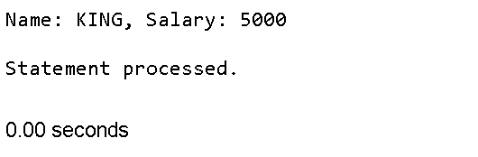
DECLARE
CURSOR salary_cursor IS
SELECT ename, sal FROM emp;
employee_record salary_cursor%ROWTYPE;
BEGIN
OPEN salary_cursor;
FETCH salary_cursor INTO employee_record;
IF salary_cursor%NOTFOUND THEN
RAISE NO_DATA_FOUND;
END IF;
DBMS_OUTPUT.PUT_LINE('Name: ' || employee_record.ename || ', Salary: ' || employee_record.sal);
CLOSE salary_cursor;
EXCEPTION
WHEN NO_DATA_FOUND THEN
DBMS_OUTPUT.PUT_LINE('No employees found.');
END;
Question 8:
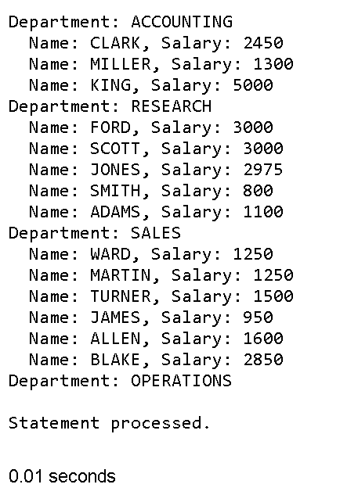

DECLARE
CURSOR department_cursor IS
SELECT dname FROM dept;
CURSOR employee_cursor (dept_name VARCHAR2) IS
SELECT ename, sal FROM emp, dept WHERE emp.deptno = dept.deptno AND dept.dname = dept_name;
department_record department_cursor%ROWTYPE;
employee_record employee_cursor%ROWTYPE;
BEGIN
FOR department_record IN department_cursor LOOP
DBMS_OUTPUT.PUT_LINE('Department: ' || department_record.dname);
FOR employee_record IN employee_cursor(department_record.dname) LOOP
DBMS_OUTPUT.PUT_LINE(' Name: ' || employee_record.ename || ', Salary: ' || employee_record.sal);
END LOOP;
END LOOP;
END;
Question 9:
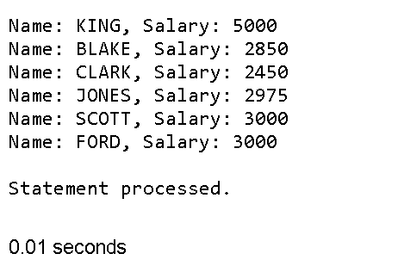
DECLARE
CURSOR salary_cursor IS
SELECT ename, sal FROM emp WHERE sal > (SELECT AVG(sal) FROM emp);
BEGIN
FOR employee_record IN salary_cursor LOOP
DBMS_OUTPUT.PUT_LINE('Name: ' || employee_record.ename || ', Salary: ' || employee_record.sal);
END LOOP;
END;

